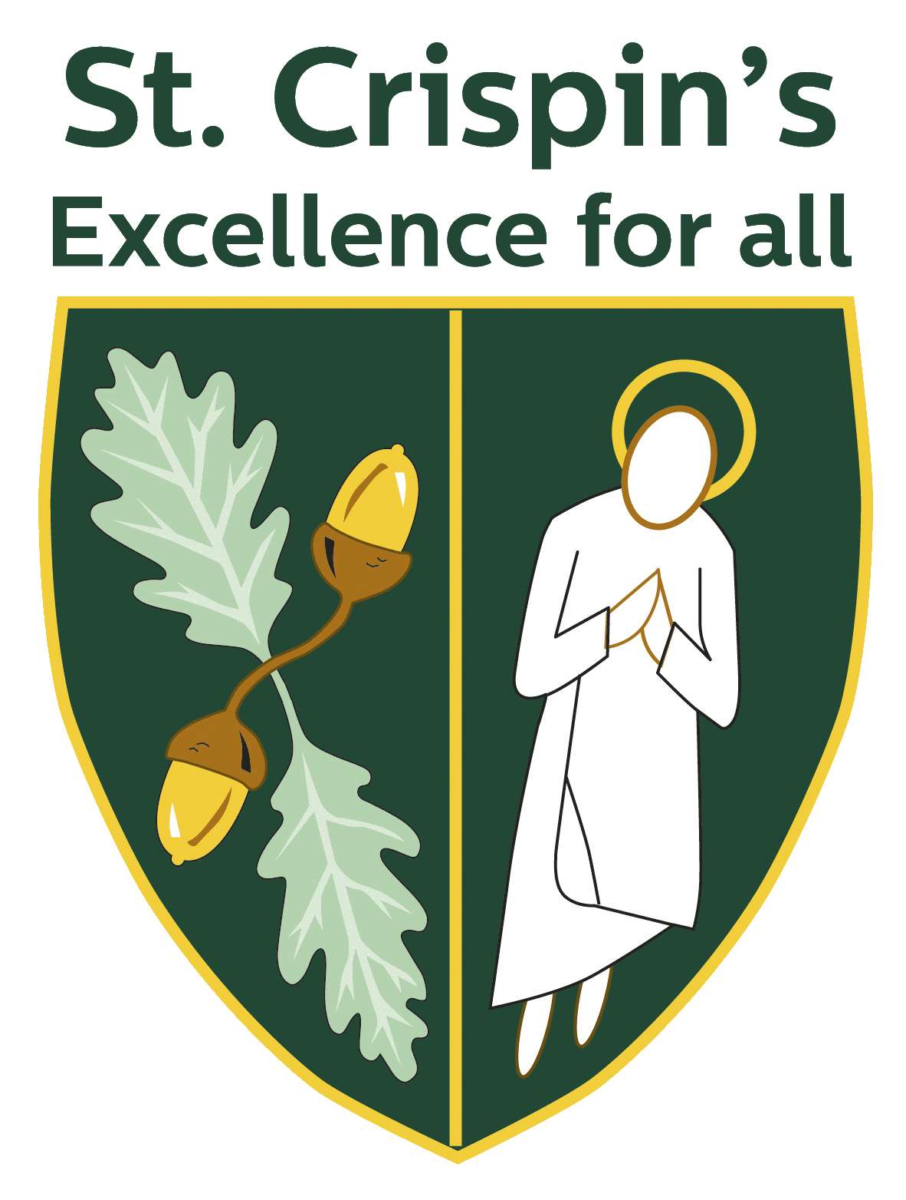

Volunteering

Gain new and transferable employability skills through volunteering. In addition to this, research completed by the NHS as part of their [‘5 Steps to Mental Wellbeing Advice’](https://www.nhs.uk/mental-health/self-help/guides-tools-and-activities/five-steps-to-mental-wellbeing/) suggests that acts of giving and kindness, including volunteering, can help improve mental wellbeing.

All students in Y12 must complete volunteering as part of their Be the Whole Package portfolio. Students in all key stages are encouraged to explore volunteering opportunities.

[Wokingham Borough](https://www.wokingham.gov.uk/countryside-parks-and-conservation/volunteering-wokingham)

[Reading Voluntary Action](https://rva.org.uk/)